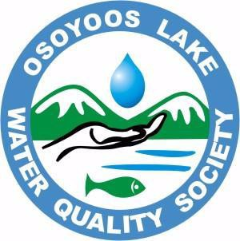

OSOYOOS LAKE WATER QUALITY SOCIETY

Please sign me up to become a member of the Osoyoos Lake Water Quality Society.
Membership is $25 per year.
I enclose $
You will be sent a tax-deductible receipt.

NAME:

ADDRESS:

PHONE:

E-MAIL:

Are you interested in becoming a volunteer? Yes/No

Additional Comments:

_

Annual Membership is $25. Donations can be submitted in three ways.

1. E-transfer $25 funds to the Osoyoos Lake Water Quality Society olwqs4info@gmail.com using your cell phone/laptop BANK APP. Also complete the information document and email it to olwqs4info@gmail.com

2. Complete information document and mail it with $25 cheque payable to Osoyoos Lake Water Quality Society Box 1382, Osoyoos BC, V0H 1V0

3. Place completed information document and $25 cheque payable to: Osoyoos Lake Water Quality Society in an envelope and deliver it in person to the Polka Dot Door 8141 Main Street Osoyoos during regular business hours.

THANK YOU FOR YOUR SUPPORT!

